December 30, 2019

Letter and evidence for Miller Organic Farm Private Membership Court Case

Purpose of the FSIS (Division of the USDA)
The Food Safety and Inspection Service (FSIS), an agency of the United States Department of Agriculture (USDA), is the public health regulatory agency responsible for ensuring that United States' commercial supply of meat, poultry, and egg products is safe, wholesome, and correctly labeled and packaged.

Purpose of Miller Organic Farm Private Membership Association
To offer food that is safe, wholesome, and provides the human body with living food to allow the individual to survive with optimal health and without illness.

This paper is designed to help those whom are concerned to understand why it is essential that Miller Organic Farm continue to be able to continue its current practices and offer foods to its private membership members.

Fact:
Cause of Disease:
Nearly every, if not all disease is caused by 2 things: environmental poisons, and deficiencies. Environmental poisons including chemical and physical poisons enter our body through the skin, mouth, nose, and eyes and as they travel through our body, they damage or completely destroy healthy cells in our body leaving cell corpses, cellular debris and the toxins themselves inside of us.

Evidence: Common examples of how toxins damage healthy cells and store in the body.

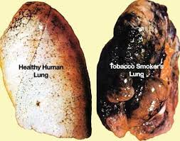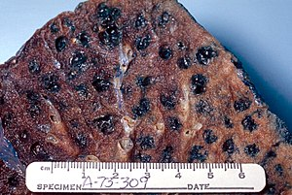
Cigarette Smoke: When toxic cigarette smoke enters the body and passes through the lungs it damages the healthy cells creating cell corpses and cellular debris, and the cigarette chemicals get lodged in the air sacs and spaces in the lungs.

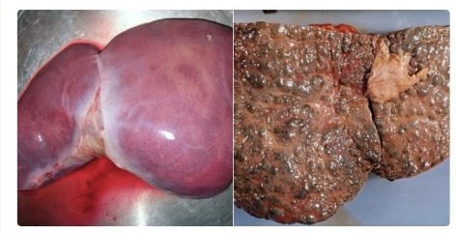
Alcohol passes through our liver and destroys healthy cells causing the liver to stop functioning.

Lead enters the brain and blocks receptors in the end of neurons preventing nutrients from entering the neurons to keep them healthy so the neurons deteriorate and eventually die.

The compound agent orange which contained the toxin dioxin was sprayed on people of Vietnam, Cambodia and Laos caused severe damage to heathy cells. Some damage so bad it killed people and some damage causing severe mutations to genes which were passed to offspring.
Even generations later.

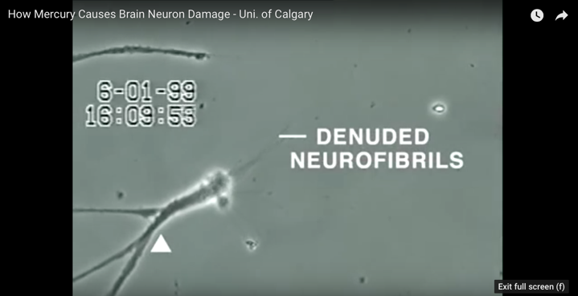
Mercury damages healthy cells completely destroying them leaving damaged neurfibrils.
https://www.youtube.com/watch?v=XU8nSn5Ezd8
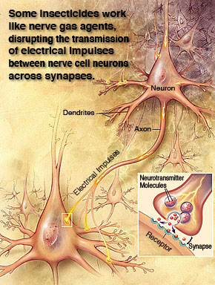
Pesticides disrupt electrical pulses in the brain scrambling them and causing misconnections.

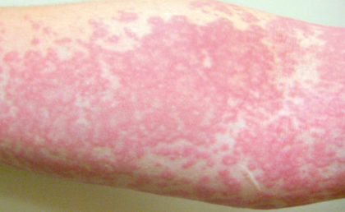
Chlorine:
When chlorine enters the body as a result of breathing, swallowing, or skin contact, it reacts with water to produce acids. The acids are corrosive and damage cells in or on the body.
https://www.health.ny.gov/environmental/emergency/chemical_terrorism/chlorine_general.htm

Fact:
Disease is not caused by bacteria, viruses, parasites and molds (aka: BVPM’s) as we have thought for so long. Although BVPM’s play an integral part in symptoms that we experience they are NOT the CAUSE of disease as we have believed. If this were true, antibiotics and other medications and the clean culture we live in with antimicrobial products would be making us healthier. Instead, disease statistics are rising year after year after year (percentages, not numbers) and this is not because we are living longer. Childhood illnesses are climbing year after year as well. It is not normal for children to be getting cancer and chronic illnesses that they are getting today.

Disease is actually a dis-ease in the host…the body. The toxins and damaged healthy cells accumulate in the body. Bacteria, viruses, parasites and molds are designed to breakdown these dead cells, debris, and toxins that have accumulated in the body without harming any healthy cells around the debris. They can reduce them to a fraction of their size so our body can eliminate them efficiently. Then, the body sends fluids to the area of the dead cells and toxins to flush them out. This is how toxins and dead cells get out of our body. The symptoms we experience …. diarrhea, vomiting, sweat, phlegm, mucus, nasal discharge, eye discharge, vaginal discharge, ear wax, skin eruptions, are all carriers to move dead cells, debris and toxins out of the body.

Think of how produce breaks down. When a piece of fruit is picked from a tree, it is no longer receiving what it needs to feed it to keep it alive. Eventually the live plant cells break down and die. When they die, mold and bacteria begin to grow on the dead cells to break them down. If you have ever left some fruit or veggies in your refrigerator a little too long eventually it can break down to the tiniest piece and water. This is exactly what happens in the body. Dead cells in the human body from toxins, are broken down by bacteria, viruses, parasites or molds and the body then gets rid of them.

When we experience symptoms like those described above, we are going through a detoxification. Whether a person makes it through the detoxification depends on whether they get the nutrition needed to rebuild new healthy cells in their body as the dead ones are being cleaned out.

Oncolytic viruses have been used at least since the early 1900’s to destroy cancer cells. This is when viruses are injected into tumors to shrink or completely eliminate them. In 1912 the rabies virus was injected into patients to treat cancer of the cervix.

Evidence: Major medical institutions are injecting bacteria and viruses into cancer cells to break them down, destroying them without touching any healthy cells around the cancerous tumors.
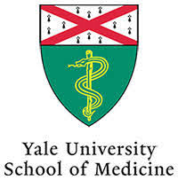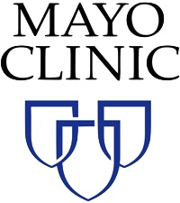
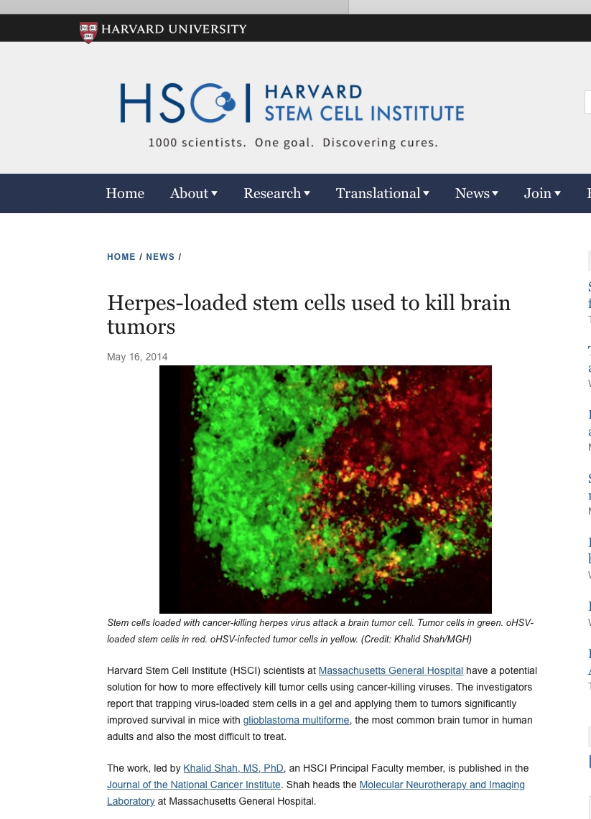
Harvard Medical School injected the Herpes virus into brain tumors shrinking tumors and not damaging any healthy cells around the tumors.

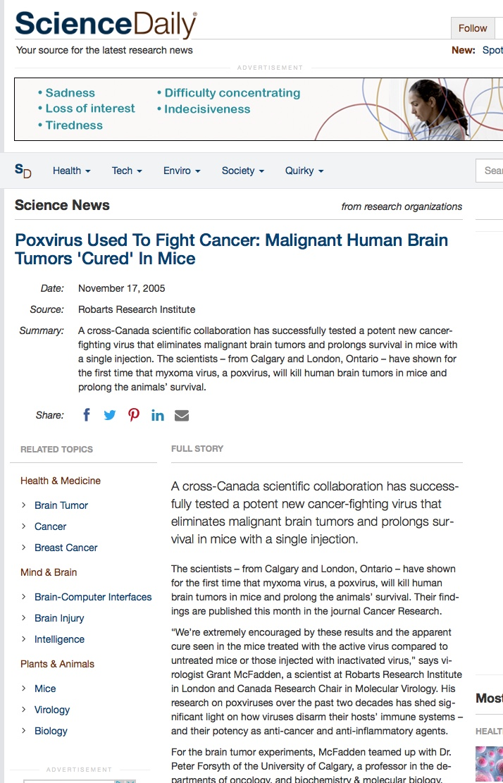
Pox virus injected into brain tumors eliminating them. Again, the virus does not harm the healthy cells in the body. Side effects are flu-like symptoms such as diarrhea, vomit, fever/sweating.
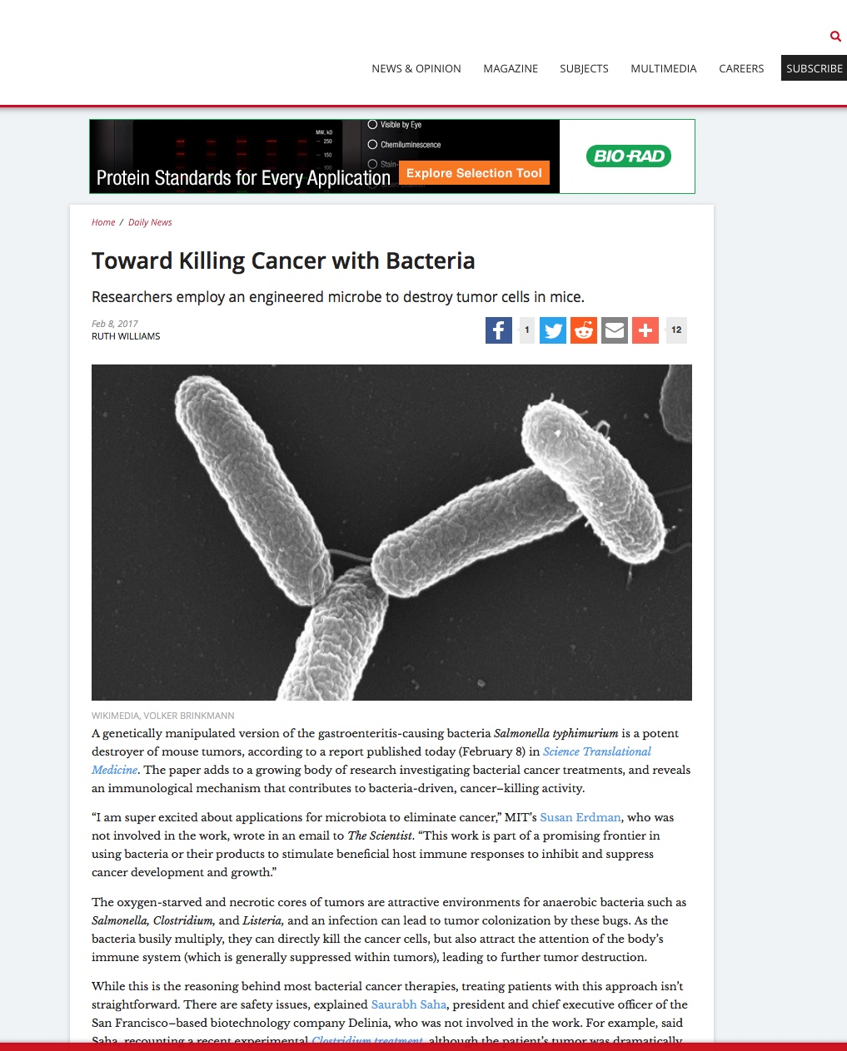
Salmonella killing cancer cells.

Fact:
We are taught that “symptoms” are bad and to stop them with medications. The medications stop the body from going through its detoxification, pushing the poisons back into the body to restore. Additional toxins are added to the body from some of the synthetic medications taken to stop the detox.

If these toxins and dead cells do not get out of the body, the body creates a capsule or cocoon around them to isolate them and protect the body. This is how a granuloma, or a tumor is created. An obvious example of this is how when breast implants are put into the body, the body tries to breakdown the implant but it is so large that it cannot so it creates a capsule around the implant to protect the body from this foreign body. See example below.
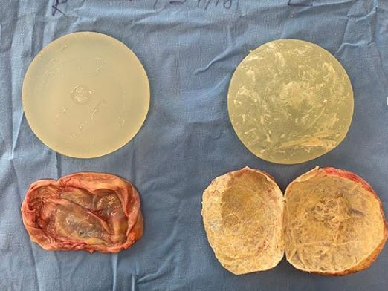

HOW DOES ALL OF THIS RELATE TO MILLER ORGANIC FARM PRIVATE MEMBERSHIP?

The membership was created because the USDA/FSIS slaughter guidelines create food that is neither safe nor wholesome for consumers because the animal protein is tainted with toxic chemicals that cause disease in humans.

Animals that are exposed to toxic chemicals in their food, water, from vaccinations, hormone injections, and medications, in addition to stress hormones that are released into their body from any stresses they are exposed to, have dead cells, cellular debris and highly caustic poisons in their body. As proven from the evidence above, when this happens, bacteria microbes turn on in the body to detoxify all of this debris. These animals have a significantly higher chance of having higher bacterial counts requiring the need for strong cleansing solutions in the slaughterhouse. This is also why larger facilities are at higher risk of bacterial outbreaks.

The chemicals frequently used in USDA verified slaughterhouses include:
https://www.fsis.usda.gov/wps/wcm/connect/24346cbd-ad28-4223-8db1-55f067ce3879/7120.1-Antimicrobials.pdf?MOD=AJPERES

Peroxyacetic Acid- corrosive/irritating to the eyes, mucous membranes of the respiratory tract, and skin. It causes lacrimation, extreme discomfort, and irritation to the upper respiratory tract in humans after exposure to concentrations as low as 15.6 mg peracetic acid/m³ (5 ppm) for only 3 min.
https://www.ncbi.nlm.nih.gov/books/NBK220001/

Acetic Acid - This liquid is highly corrosive to the skin and eyes and, because of this, must be handled with extreme care. Acetic acid can also be damaging to the internal organs if ingested or in the case of vapor inhalation.
https://www.msdsonline.com/2014/11/19/acetic-acid-hazards-safety-information/

Sulfuric Acid- a highly corrosive chemical that is potentially explosive in concentrated form. It can cause severe skin burns, can irritate the nose and throat and cause difficulties breathing if inhaled, can burn the eyes and possibly cause blindness, and can burn holes in the stomach if swallowed.
https://www.atsdr.cdc.gov/phs/phs.asp?id=254&tid=47

1-hydroxyethylidene-1 – harmful if swallowed.
https://pubchem.ncbi.nlm.nih.gov/compound/1-Hydroxyethanediphosphonic-acid_-sodium-salt#section=GHS-Classification

Chlorine:
When chlorine enters the body as a result of breathing, swallowing, or skin contact, it reacts with water to produce acids. The acids are corrosive and damage cells in or on the body.
https://www.health.ny.gov/environmental/emergency/chemical_terrorism/chlorine_general.htm

Volume Of Animals That Are Run Through The Facility
There is a high volume of animals that are moved through the large USDA facilities. Miller Organic Farm processes such a low volume, sending one animal a day is not practical and there is a very high chance that the Miller Farm animal would get lost as there is no guarantee that the slaughterhouse could give the exact meat back to Miller’s from the exact cow that was sent there.

Slaughter
Shipping an animal to the slaughterhouse puts very high stress on the animals. They are trucked or trained into the facility where they watch the other animals being slaughtered. It is alike to the concentration camps where the Jews were packed in trains and brought in and watched the others go into the facility where they were killed. Animals know what is happening. On the Miller farm, the animals live their life in a calm environment and one animas is taken at a time away from the others when it is their time. There is no stress of travel and watching others be killed and it is done with one shot so it is instantaneous.

There are USDA approved slaughterhouses that improperly kill and torture animals as documented in video by PETA. https://www.peta.org/features/agriprocessors/
How can you guarantee that Miller animals will not go to facilities like these? You cannot. At least at Miller farm, I know what the food I am putting into my body and the body of my family has been through.

Fresh VS Frozen
The members of the Miller co-op desire fresh not frozen meat. These are individuals who want to live and survive in this life in optimal health so not only do they not want chemicals on their meats from the processing that would go into their own body causing dis-ease, but they desire their meats fresh not frozen as frozen meat is hot as healthful. When meat is frozen, the water in the meat forms crystals. The sharp edges of crystals can damage healthy live cells in the meat causing there to be dead or damaged cells in the animal meat. As mentioned above, the body sees dead cells (whether from your own body or from dead cells you put into your body) as a form of toxin that it needs to clear out. We want to put living cells from fresh meat into the human body to sustain life. In addition, most people do not have the financial means to purchase large amounts of product at one time nor do they have the freezer space to store it.

Summary:
Today we have a cure for cancer. We have a cure for disease, chronic illnesses, and pain. The cure is prevention…prevention by not exposing the body to toxins in the first place, and through detoxification of the toxins we are exposed to. The first rule in getting healthy is to turn off the faucet of poisons. We know that environmental toxicity causes every one of these diseases and we have the power to prevent them from happening if we are given healthy choices. The members of the Miller Farm private group understand the importance of taking responsibility of their own health by turning off the faucet and are taking action by buying meats that are chemical free (or as chemical free as they can get). But if FSIS/USDA and the United States government do not allow Miller farm to continue their practices of raising and slaughtering in truly humane ways and providing healthy chemical-free animal products to those who choose this, then we have lost the democratic way in our country and we have become a dictatorship that is contributing to the increase in cancer, chronic illness and the death of the American people by forcing us to ingest toxic food instead of life-giving chemical free food. By not giving us a choice, our government can be held accountable for the sickness and death of its own people.

Are there slaughter houses out there doing horrible things? Absolutely! But forcing these regulations on people will only contribute to more disease as it will create more hate, more resentment of our government and more disease from these stresses and the mental poisons that will exist in addition to the actual chemical toxicity. It is no wonder our country is so ill.

The Meat and Poultry acts were put into place with the best of intentions to protect the American people so they can have food that is both safe and wholesome. When that was put into place we did not have all of the information and science that we have today. We now know that chemicals are not safe. Not in any quantity. The smallest amount combined with the smallest amount, and the smallest amount, and the smallest amount ……. All combine causing severe damage to organs, glands, vessel, bone, the brain, the heart, etc.

Is there a place for these regulations in the instance of animals that are given toxic food and highly medicated and vaccinated and slaughtered in a huge facility where it is more difficult to control the levels of bacteria? Yes. There is a place for these regulations. Even in this instance, there are more natural products that destroy bacteria even better than the chemicals they are currently using and are non-toxic. I suggest the USDA look into these products. I do not sell or represent companies who make them but I can suggest at least one company from Michigan called “Better Life” that makes a natural bacteria eliminator that is more powerful than industrial chemicals on the market, yet eliminates bacteria levels even better than chemicals.

Prayer for Relief:
- We respectfully request the court allow the American people the choice of how their food is raised and slaughtered so we can choose healthy life-giving food, not poisoned meat that is full of chemicals that cause disease and illness.
- If there is no choice, the government will also be violating religious freedoms for those who slaughter according to one’s biblical traditions such as in small conscious Kosher slaughterhouses.
- I suggest the USDA investigate and implement natural disinfectants such as those made by “Better Life”, to be used in the regulated facilities to reduce the caustic poisons that are in the meat and consumed by consumers causing illness and disease.
- I recommend live feed cameras be mandated in all facilities so consumers….the American people, can see with their own eyes what is happening to the animals they are buying for food. People are becoming more educated and are demanding full transparency. Unfortunately, the unscrupulous among us have caused this to have to happen, but it is an opportunity to give the American people trust again. They can trust because they can tune in at any time to see with their own eyes that everything is the way it is supposed to be. There is no way we have enough people to go out there and watch what is happening and no one knows what goes on behind closed door when inspectors leave. Live-feed cameras take the guess work out of the equation and allow inspectors to do a large amount of their work from their computer which will save the government a tremendous amount of money.

Thank you for your time. I know the intent of FSIS/USDA in this case is good, but the impact is exactly the opposite. Please feel free to contact me if you have any additional questions.

Sincerely,
Kimberly Lynn Williams
Researcher, Author, Consultant and detoxification specialist.
www.KimberlyLynnWilliams.com
Kim@KimberlyLynnWilliams.com
424-335-9335
“Raw to Radiant: the secrets to a long life of radiant health”, by Kimberly Lynn Williams
